Comments
1. Remove meeting scheduling option from here. - Done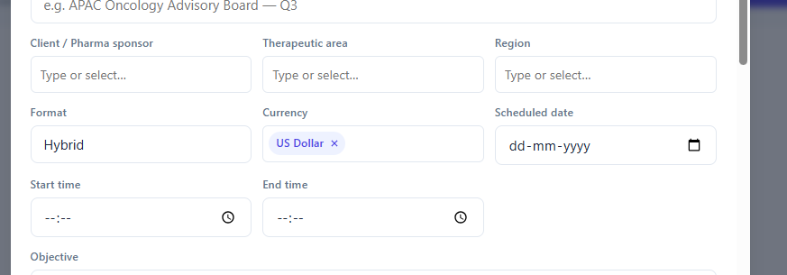
2. The meeting link I sent is still coming from TuraDome@turacoz.com. Please change the ID. - Done
3. Only the meeting link is being shared. I am not able to share the documents and survey link. We should be able to share the survey link or slide deck or prereading material with the experts along with meeting link or separately. - Done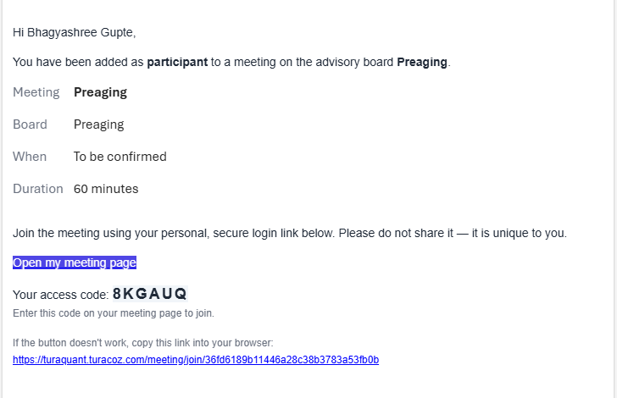
4. No one was able to join the meeting from the link I sent via email. Check below screenshot. They were able to join the meeting link when I shared zoom link with them. - Done
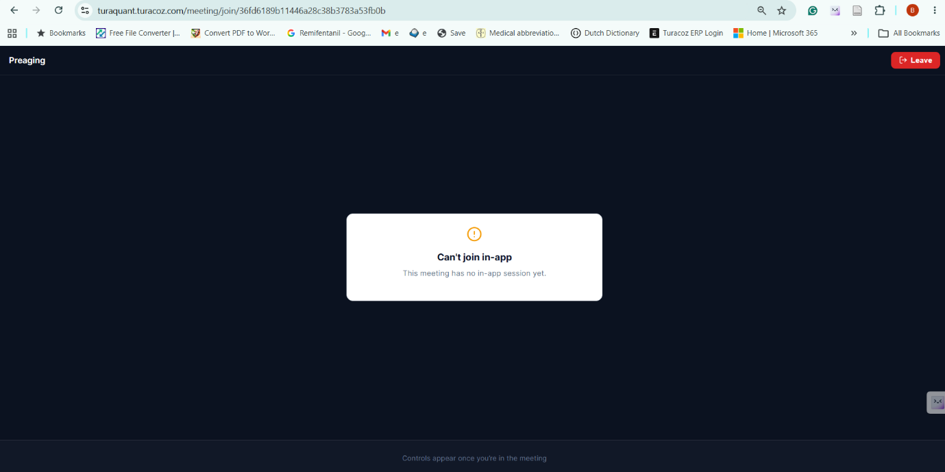
5. It was showing that my mic media is not ready yet for all the options. - Done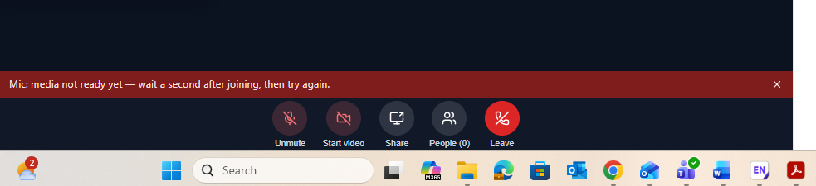
6. Organizer is not able to record the meeting. The option to record was with the participants but participants should not know that we are recording them. Only the organizer should have that option.
7. Give two options to schedule the meeting, one for timing and one for date like we do in outlook. This way it is confusing.
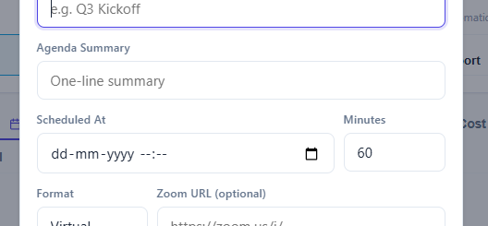
8. The linked survey or documents were not accessible in the meeting. - Done
9. Bhagyashree recorded the meeting and received video recordings on mail but bhagyshree was the participant she is not supposed to record or receive recordings. Organizer or medical writer should be able to record and receive the recordings. - Done
10. We recorded the meeting, but no transcript or summary was generated. We checked the platform also there was no transcript or summary for our meeting. Kindly check. - Done
11. recording.conf named document was also received by Bhagyashree. This is not required. Audio and video are fine. With audio and video organizer should receive transcripts and summary. - Done
{"items":[{"audio":"audio1325778786.m4a","prefix":"","process":100,"video":"video1325778786.mp4"}],"magic_number":"325778786"}

